The Crime Landscape of Salt Lake City

# Basic Information

Members:

* Archit Rathore – u1144416 (archit@cs.utah.edu)
* Yash Gangrade – u1143811 (yashgangrade09@gmail.com)
* Rebeka Mukherjee – u1141112 (rebeka.mukherjee@utah.edu)

Github Repository: <https://github.com/yashgangrade09/dataviscourse-pr-crime-landscape.git>

Contents

Basic Information 1

Motivation 2

Questions 2

Data Collection and Processing 2

Implementation 3

Page Structure 3

Year Slider 3

Map View 4

Selection View 6

Summary View 6

Statistics View 7

Appendix – Proposal Images 8

# Motivation

The general consensus between us team members was to work with data that pertained to some societal factors. Another thing that we wanted out of our project was to be able to derive insights on a much finer geospatial resolution (state/city). Finally, we also wanted our visualization to be relatable and not dealing with data of a technical nature. This led us to explore the Utah Open Data catalog (<https://opendata.utah.gov/>) and we finally zeroed in on the police cases dataset that lists all reported crimes in the Salt Lake county.

This dataset checks off all our boxes, namely:

* Pertains to societal factors
* Is localized
* Is relatable and may be of equal interest to both a layman and a specialist
* Has the potential to inform policy decisions

# Questions

Many questions arise when we were creating the visualizations and processing the data. Some of them are listed below;

* What’s the general crime landscape in Salt Lake City and how it has changed over the years? Essentially, an overview about the living in Salt Lake City.
* Are there any crimes that have been constantly increasing over time?
* If a person wants to buy a house, he/she can query what kind of crimes are prevalent near the location.
* How’s one neighborhood different from other neighborhoods in terms of crime types?
* What hour of the day/night is the most dangerous in terms of crimes in a neighborhood? Ex. what’s the number of stealing incidents on Friday or Saturday night etc.

# Data Collection and Processing

As we discussed before, we are using the [Police cases dataset](https://opendata.utah.gov/Public-Safety/SALT-LAKE-CITY-POLICE-CASES-2016/trgz-4r9d) from 2008-2016 from Utah Open Data catalog. Each record in the data corresponds to an instance of reported crime at one of the police stations in Salt Lake City. It contains information about the type, time and date of occurrence and reporting, and location of the crime. There are about 50K+ records per year. The data is open access.

For data clean up, we drop the rows where any piece of vital information like X-coordinate, Y-coordinate, Location, Time etc. is not available. We also need the Latitude and Longitude information of the location of crime using the given coordinates information. In the data, we are given X and Y coordinates which needs to be converted to Latitude and Longitude.

For now, to create and work with different views in visualization, we are using small subset of dataset for three years with a few data points in each file. We took ten data points for each year from 2008 – 2010 and then we got the latitude and longitude manually from the google maps by entering the street address.

For geospatial data, we tried a few different ways to fetch and display the data namely Google Maps, OpenStreetMap, OpenLayers etc. and we are finally using Leaflet library for displaying the map. This is also a mobile friendly and responsive design of the map, so it will be beneficial and easy to use for everyone.

# Design Evolution

## Proposal Design:

In our main proposal design, we had three different views namely Map View, Selection View and Statistics View to show the yearly, monthly, weekly and hourly statistics. Details of the design are as follows:

* The map view shows the location points of crimes selected in selection view and time selected by the time slider. The mark used is points and channels are color (type of crime) and position (location of crime).
* A time slider enables the user to see the trend of crimes over the years. On clicking the year slider, it expands to show the months for the selected year. This enables the user to visualize the crime trends on a finer scale. It collapses to show only the years when clicked again.
* A selection view enables users to select the crimes they wish to visualize through checkboxes.
* The map view has a semantic zooming feature with zip code level aggregation at the topmost level and blocks at the lowest level.
* The statistics view shows yearly, monthly, weekly and hourly statistics of aggregated data about selected crimes as line charts.
* All the views will be linked to each other. For example, clicking on crime selection view will update the map view as well as the statistics view.

Our proposal design looked something like this:

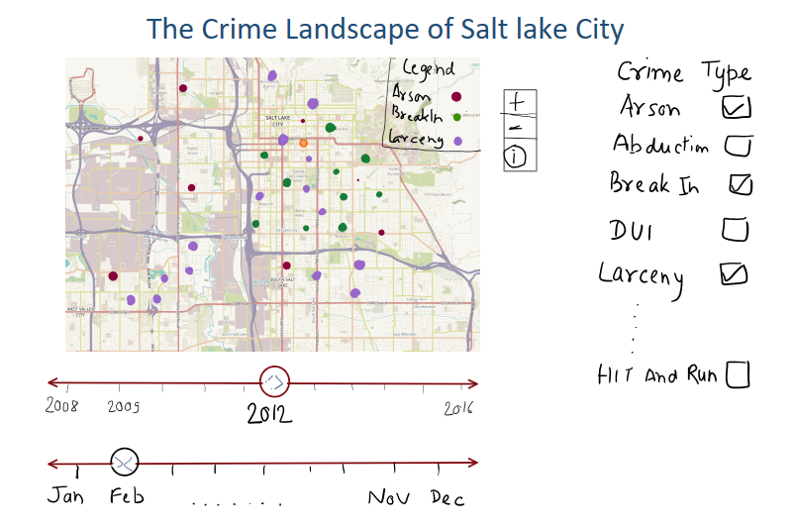

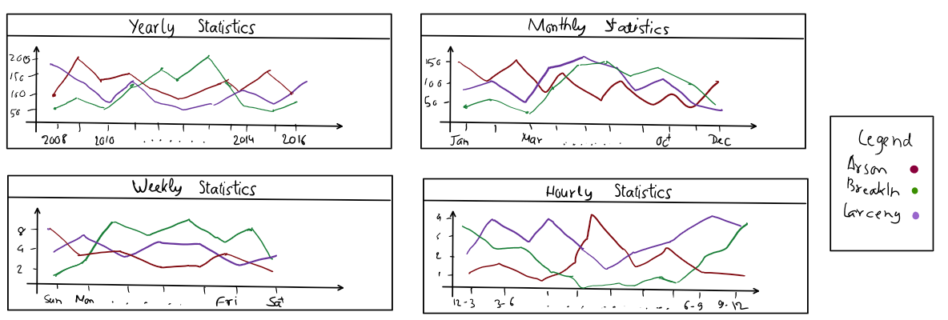

Apart from the main design, we also submitted three prototypes of alternative designs which might be useful. We are using one of the prototype designs and creating a pie chart which will demonstrate the distribution of crimes over a year.

## Changes and Improvements in Design over the course of project

We made quite a few changes in the design with respect to all the views.

1. **Map View**

For each year, we had nearly 60000 rows in the data i.e. ~60K crimes per year.

As a first attempt, we were trying to plot all the crimes using small circles with varying opacity. But, since the density of the crimes is so high, we ended up with our map fully crowded with Data points. Also, getting relevant information from this was very difficult.

Second, since the above design wasn’t working the way we wanted so we tried using heat maps for representing the crimes. It’s a good visualization but the problem here is, we can represent only one crime on the map if we are using a Heat Map. Thus, if the user wants to compare multiple crimes in the same year, it’s not possible in this method. We scrapped this idea.

Third, we shifted to the map design which uses Markers to represent the crimes according to the Latitude and Longitude information. Here, we also employed different color markers to differentiate the crime types. It was working fine, and we used robust leaflet libraries to draw markers on the map. Although, the main problem here is, since the data is so large in terms of rows that in some cases there will be too many markers on the map and that would cover the entire map. For an instance, this is the screenshot of a map containing merely 25-30 points and it’s already very crowded. 60000 points on this map is definitely not an effective solution.

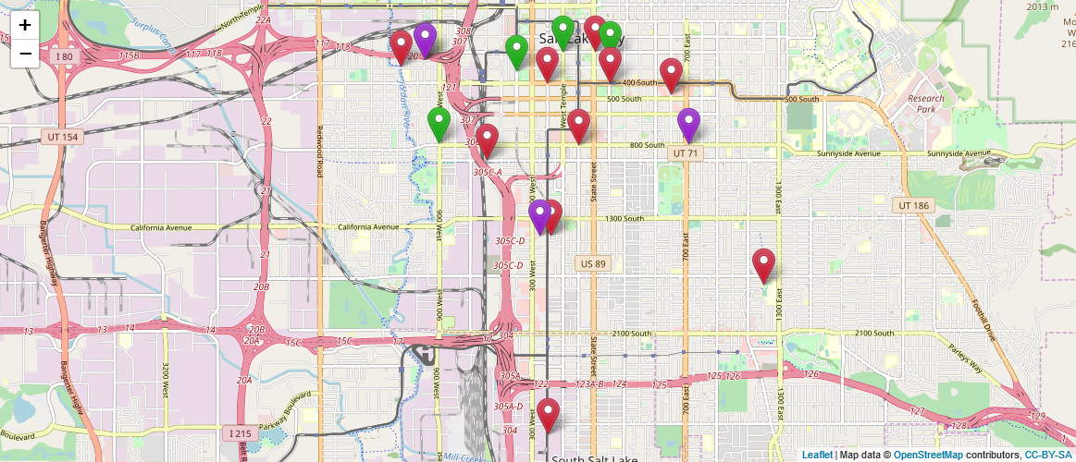

To rectify the above problem, we went with aggregation and clustering of the data points on the map and add Semantic Zooming to get a clean map view. Here, the visualization will start with a high-level overview of the number of crimes (in form of bubbles) in different areas of Salt Lake City and then the user can zoom in to the map and it will unfold the number of crimes into smaller bubbles and individual markers. A user can also click on any of the areas to automatically zoom in to that area.

Another addition we did here was to create the groups of markers according to the selected crimes. For example, a user selects “Assault” and “Traffic” through the selection view. Markers for those will appear on the map. A user can then chose from a overlay in the map to show only Assault or Traffic markers

# Implementation

## Page Structure

We first created the basic structure of the directory and created the views structure of the visualization. First, we created a container which holds all the views and structure in several nested divs. Each div represents a view like map-view, summary view etc. and we are assigning classes to each of the divs. This assists us in arranging the divs according to the structure required. Also, we can work on a view separately without disturbing the entire structure. Below is the initial starting structure of the visualization.

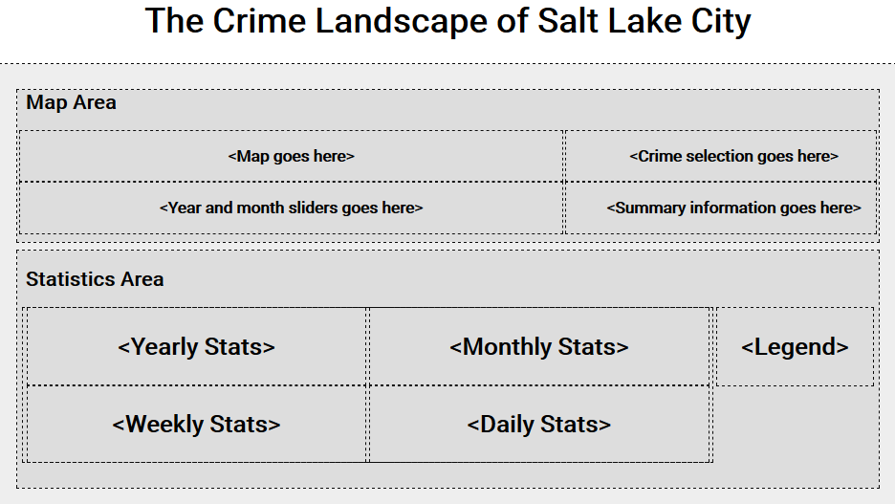

## Year Slider

The visualization needs a year slider to update the map when the year is changed. We directly used the year slider structure from the Gap Minder HW here. Similar slider will be attached for the month data as well. An image of year slider is attached below.



## Map View

One of the key elements in our visualization is the map view of Salt Lake City county. We want to fetch the data from the server then display it along with different markers for the crimes. For this, we evaluated three options namely, Google Maps API, MapBox, and OpenStreetMap for fetching the map data of Salt Lake City. We finally selected OpenStreetMap to do this because it’s free and it doesn’t restrict the number of requests, modifications to the maps etc. Then, to display the data we again explored multiple options like OpenLayers, GoogleMaps, Leaflet etc. and we finally selected Leaflet to display the map (data from OpenStreetMap) for our visualization. We centered the map at Salt Lake City and kept a marker at our home address for testing. Initial Map is shown below.

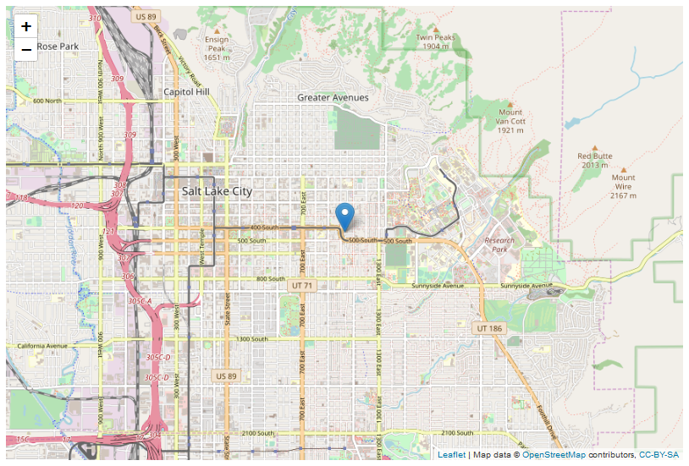

Next step was to create markers for different crime types at different locations. For this, we converted the CSV data to a JSON object and then we use this JSON object to put different markers and assign different icons to them according to the crime type. The map and the markers get updated if the year is changed. Clicking on any marker will open a small popup showing information about the location and crime. An example of map with markers is shown below for the years 2008 and 2009.

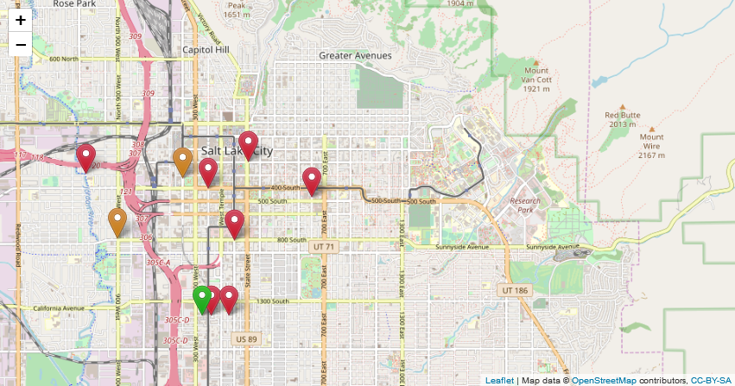

Crimes in year 2008 (each color represents a different type of crime)

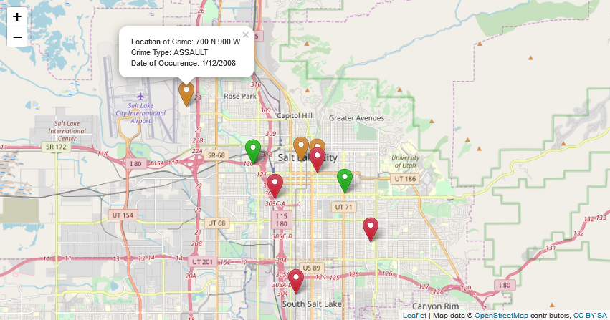

*Crimes in year 2009 (popup shows more information about the crime)*

We realized that these markers are not the best way to represent the crimes in Salt Lake because with large dataset, markers will cover most of the map and thus it will become hard to infer use information from the map. We plan to change the markers to heat maps or we will use location based aggregation for the markers by crime type etc. We also can try to use hue and saturation to represent different types of crimes in the clustered view.

## Selection View

In the selection view, we currently have a small subset of crimes to select from. They are also shown as checkboxes which will be later changed to multiple select checkboxes in textbox (something like LinkedIn Skills section) to accommodate all the type of crimes. Currently, our selection view is not functional as in we haven’t appended the update function to the “Apply Filters” option.

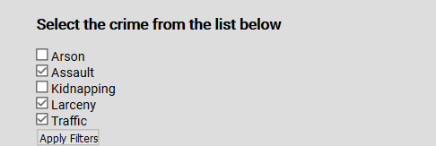

Selection View (will change for the final design)

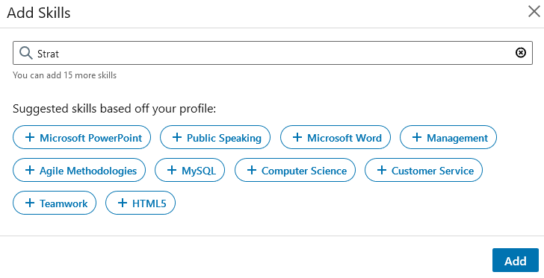

Example of desired Selection View

## Summary View

We are using Doughnut chart from Chart.js and it’s demonstrating the ratio of incidents of selected crimes against total crimes. We understand that this might not be optimal, and we may have to opt for some other form of visualizations.

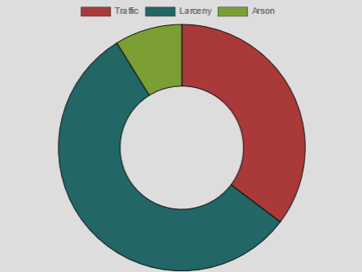

## Statistics View

This view uses the data from different years, months, days and even hours. We are creating four different line charts for Yearly, Monthly, Weekly, and Hourly statistics. Here, we will be using different colored lines to show the trend over different temporal quantities. We can compare multiple different crime and understand their correlation with each other and with different times. For example, we can see that traffic accidents increases in the evening time because it’s usually high traffic that time. We will explore more visualizations like bar chart, pie chart etc. and see which visualization conveys the information in the most efficient and informative way.

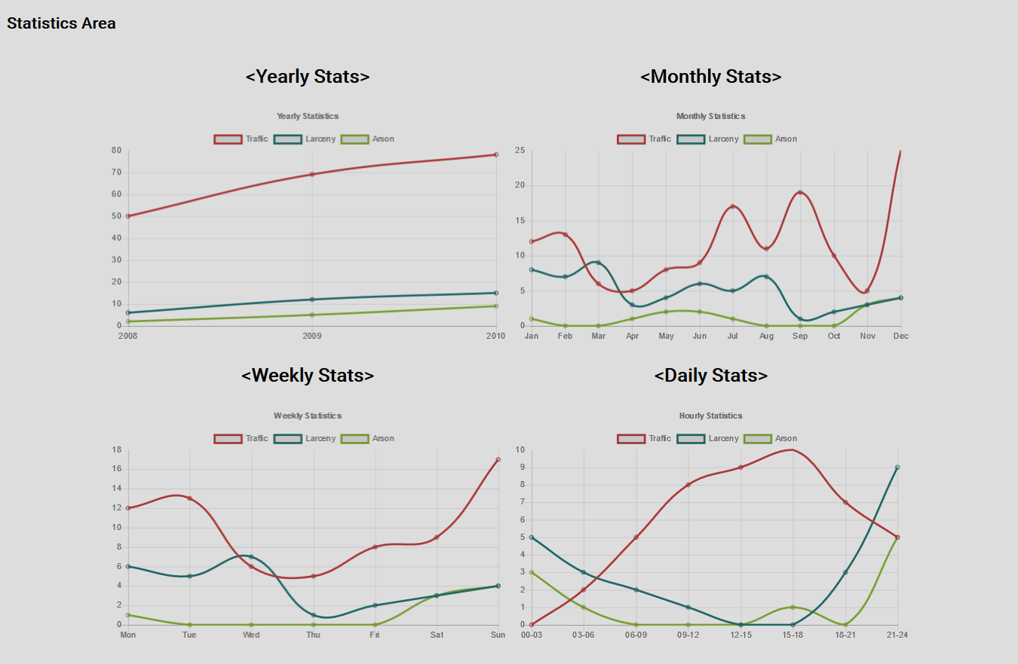

# Appendix – Proposal Images

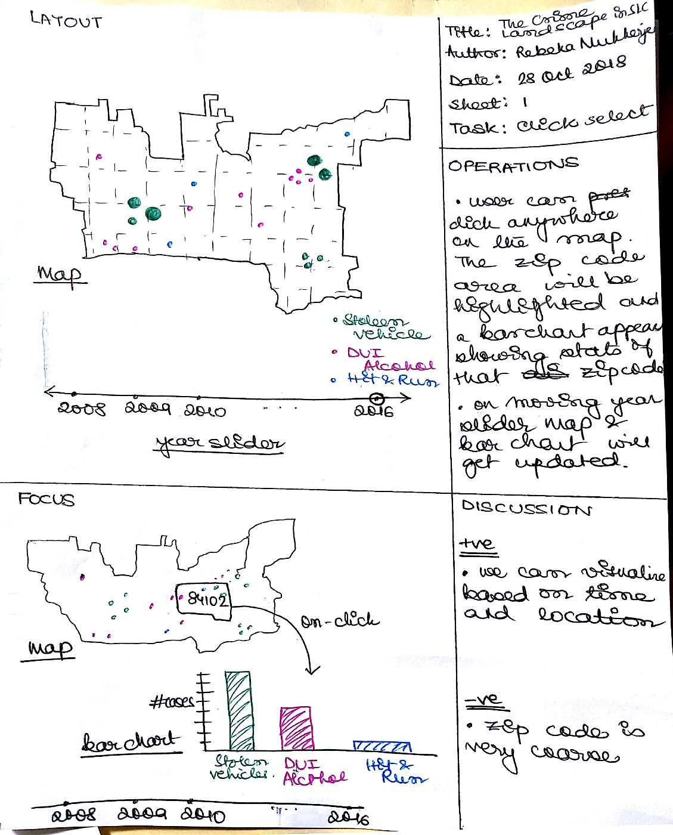

Prototype 1 Design

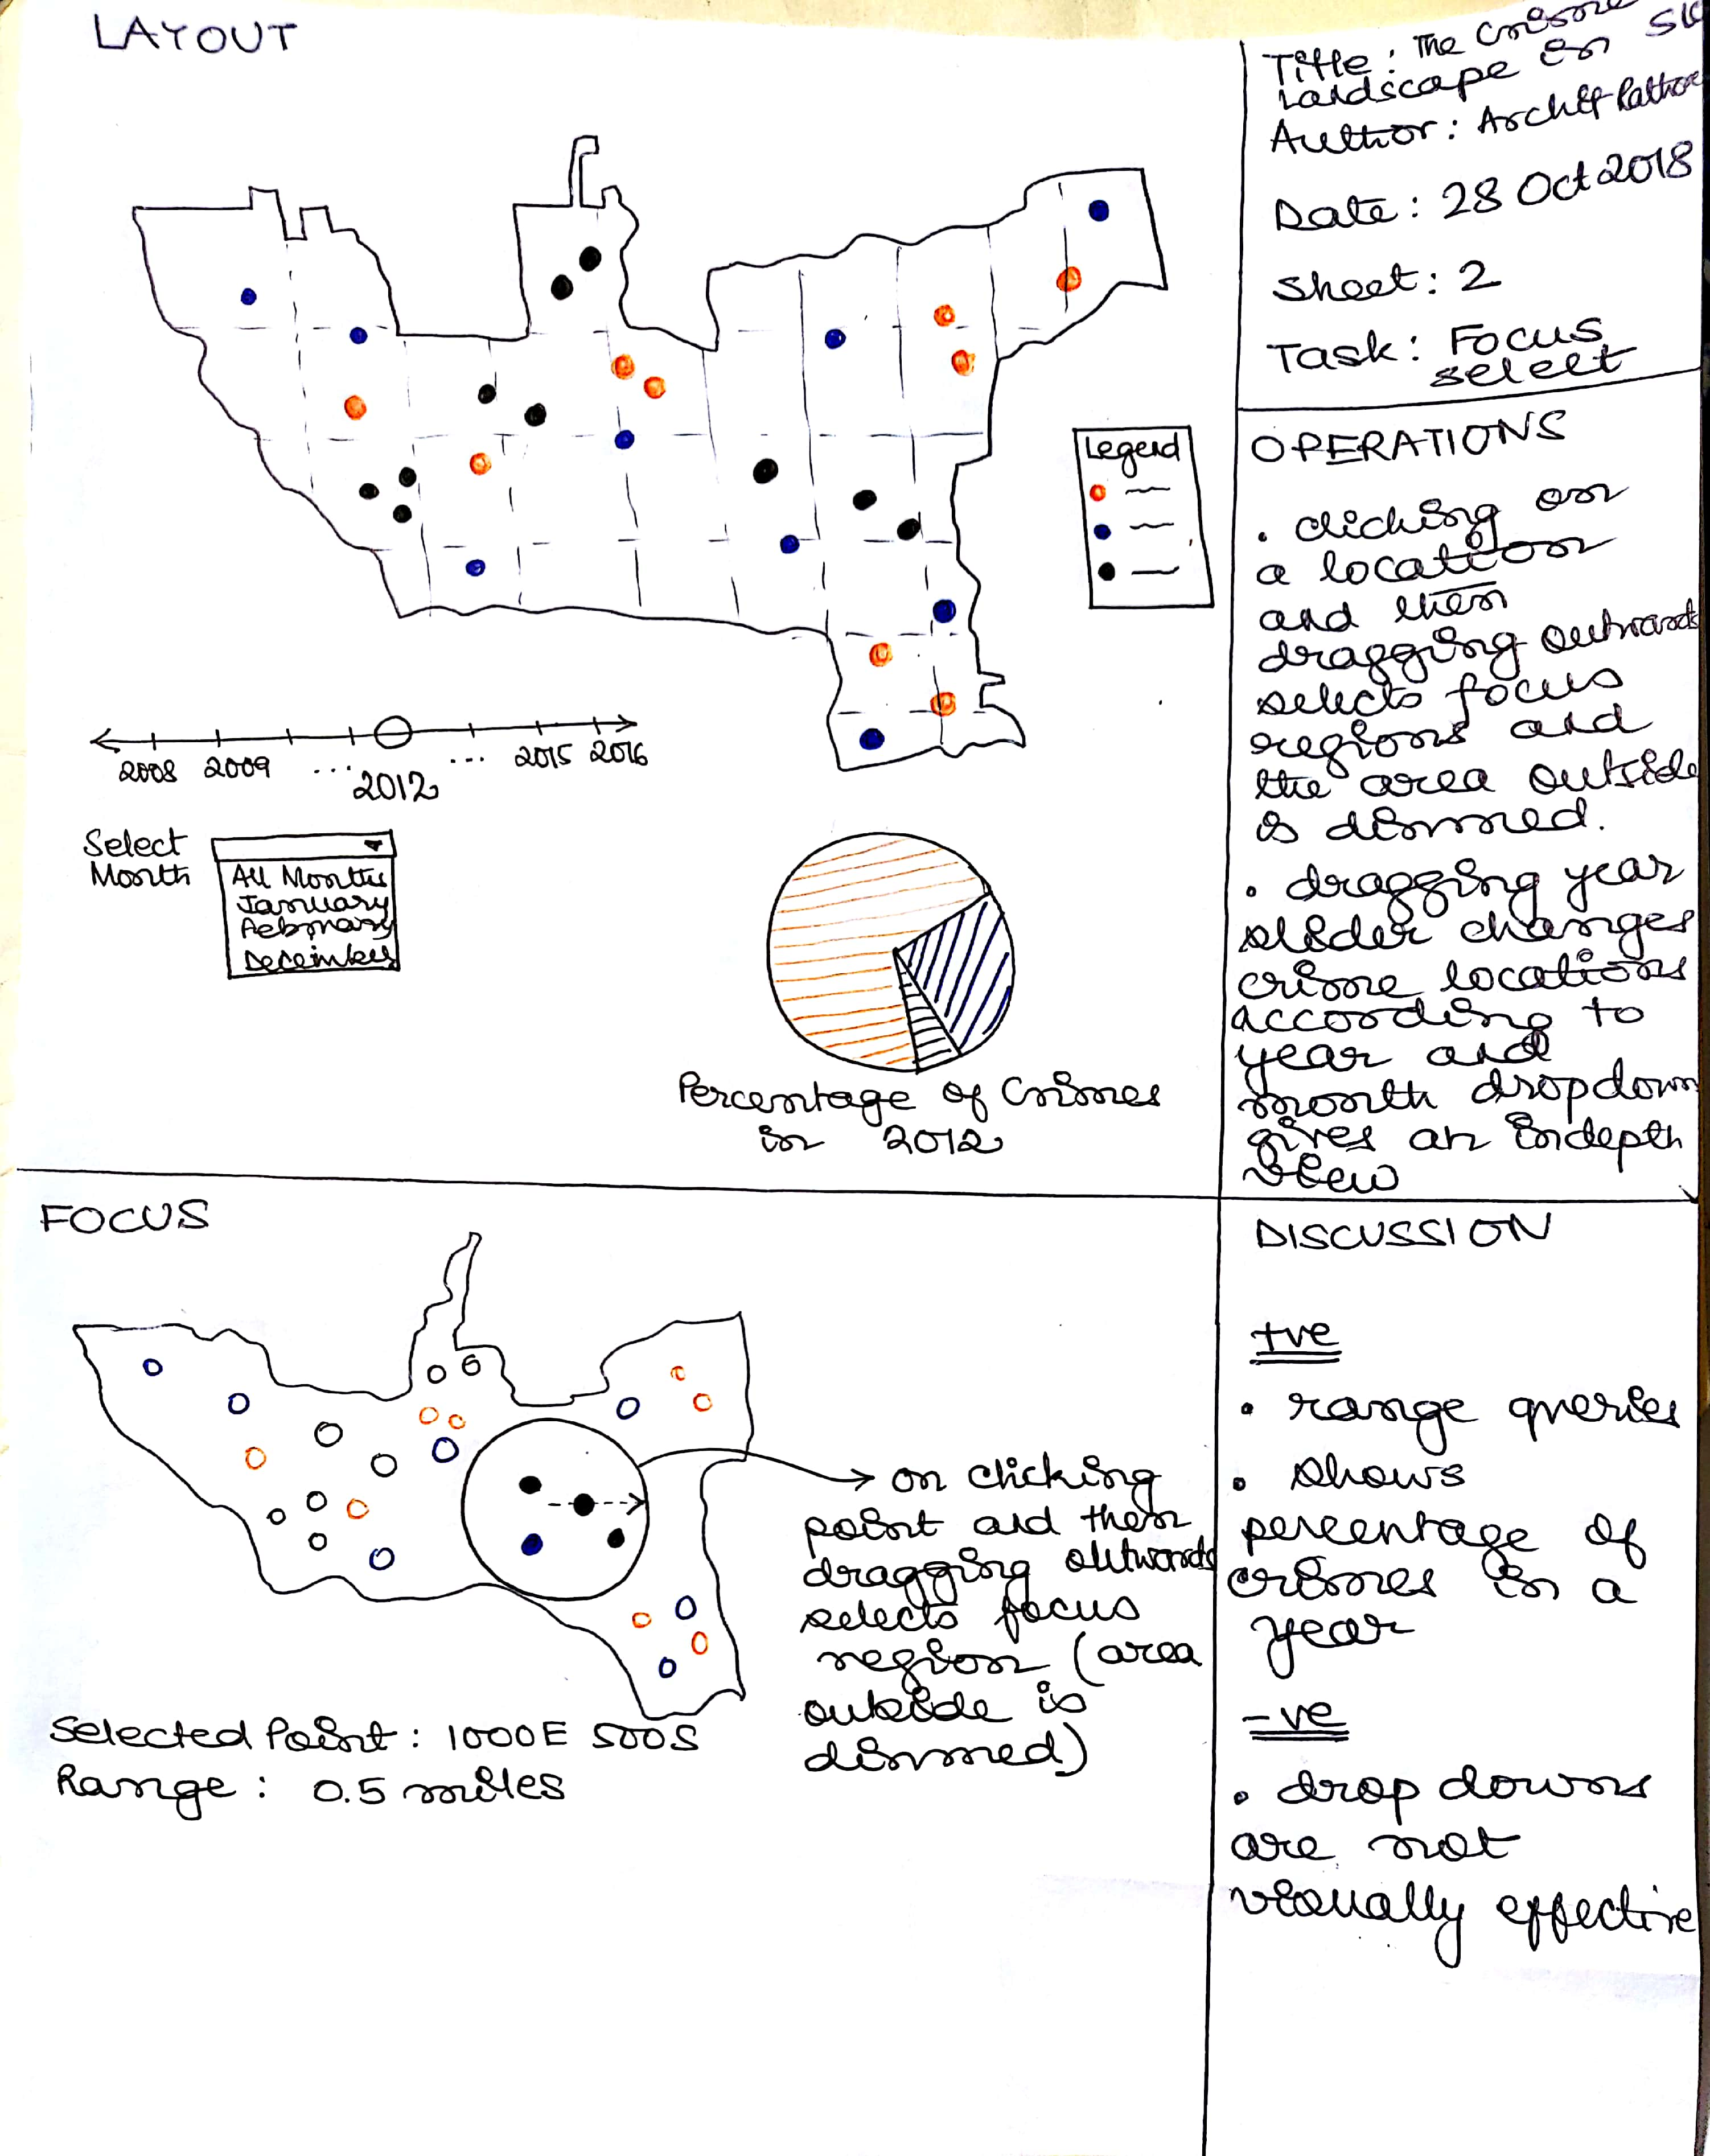

Prototype 2 Design

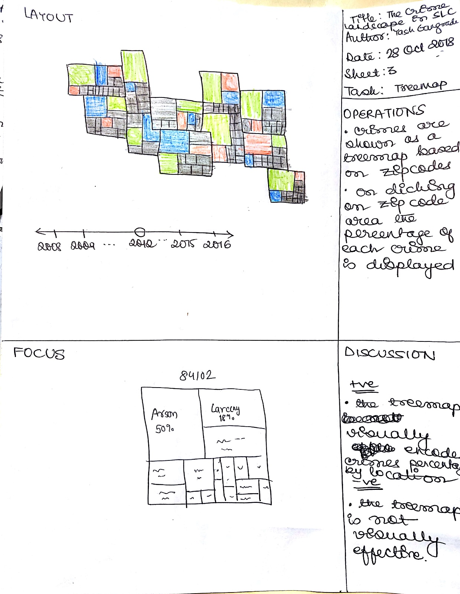

Prototype 3 Design





**Final Design**